**T.E.A.R.**

**T.E.A.R.**

**Table of Contents**

Player Characters…………………………………………………………………………………………………………………………………5

Blorg…………………………………………………………………………………………………………………………………………………….6

Crimson………………………………………………………………………………………………………………………………………………..7

Hodolia…………………………………………………………………………………………………………………………………………………8

Serena…………………………………………………………………………………………………………………………………………………..9

Sudok……………………………………………………………………………………………………………………………………………………10

Vex.......................................................................................................................................................…...11

T.E.A.R. ………………………………………………………………………………………………………………………………………………..13

Backstory……………………………………………………………………………………………………………………………………………..14

Introduction………………………………………………………………………………………………………………………………………….15

Desira……………………………………………………………………………………………………………………………………………………19

Backstory………………………………………………………………………………………………………………………………………………20

Map………………………………………………………………………………………………………………………………………………………21

Points of Significance…………………………………………………………………………………………………………………………….22

* + The Town
  + The Forest

The Hall of Portals…………………………………………………………………………………………………………………………………24

* Gargoyle Guards
* Transportation

Darkteir Castle………………………………………………………………………………………………………………………………………27

Outside…………………………………………………………………………………………………………………………………………………29

Basement……………………………………………………………………………………………………………………………………………..32

Floor 1………………………………………………………………………………………………………………………………………………….34

Floor 2………………………………………………………………………………………………………………………………………………….36

Floor 3…………………………………………………………………………………………………………………………………………………..38

Floor 4…………………………………………………………………………………………………………………………………………………..40

Floor 5…………………………………………………………………………………………………………………………………………………..42

Ending + Epilogue

Ending+Epilogue…………………………………………………………………………………………………………………………………...44

Works Cited…………………………………………………………………………………………………………………………………………..45

**Player Characters**

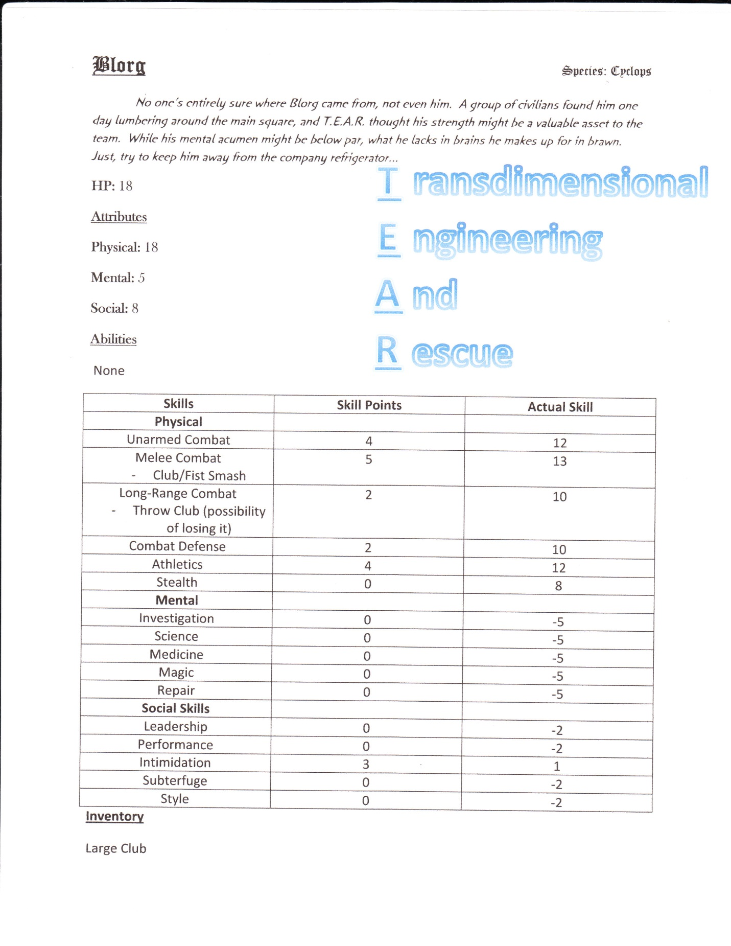

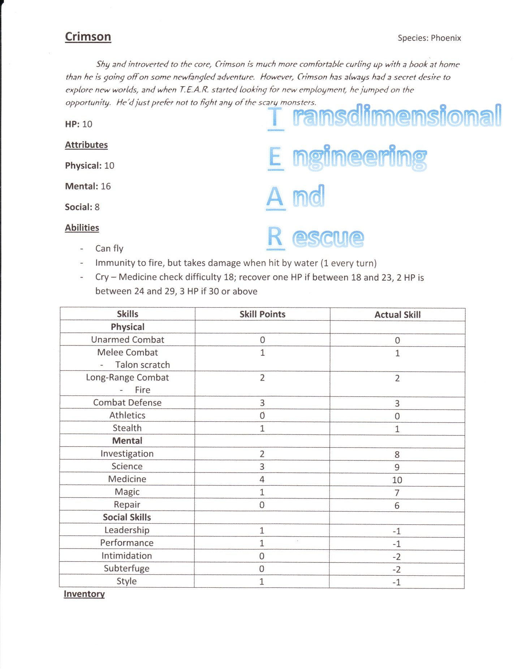

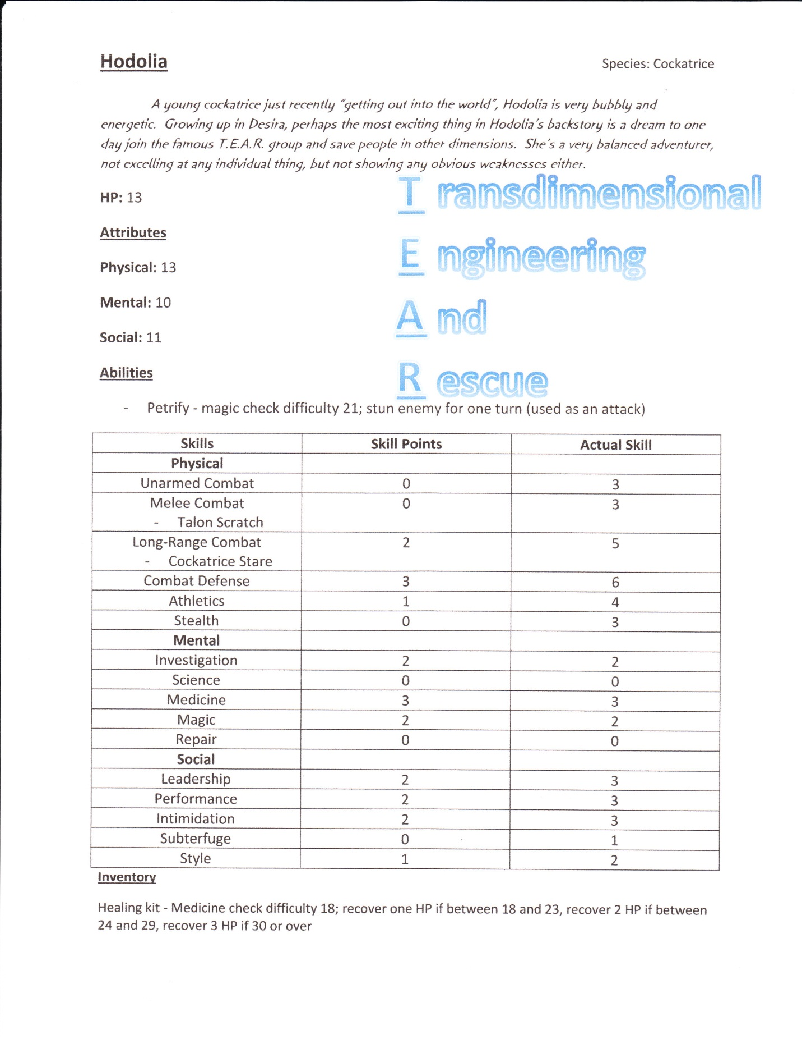

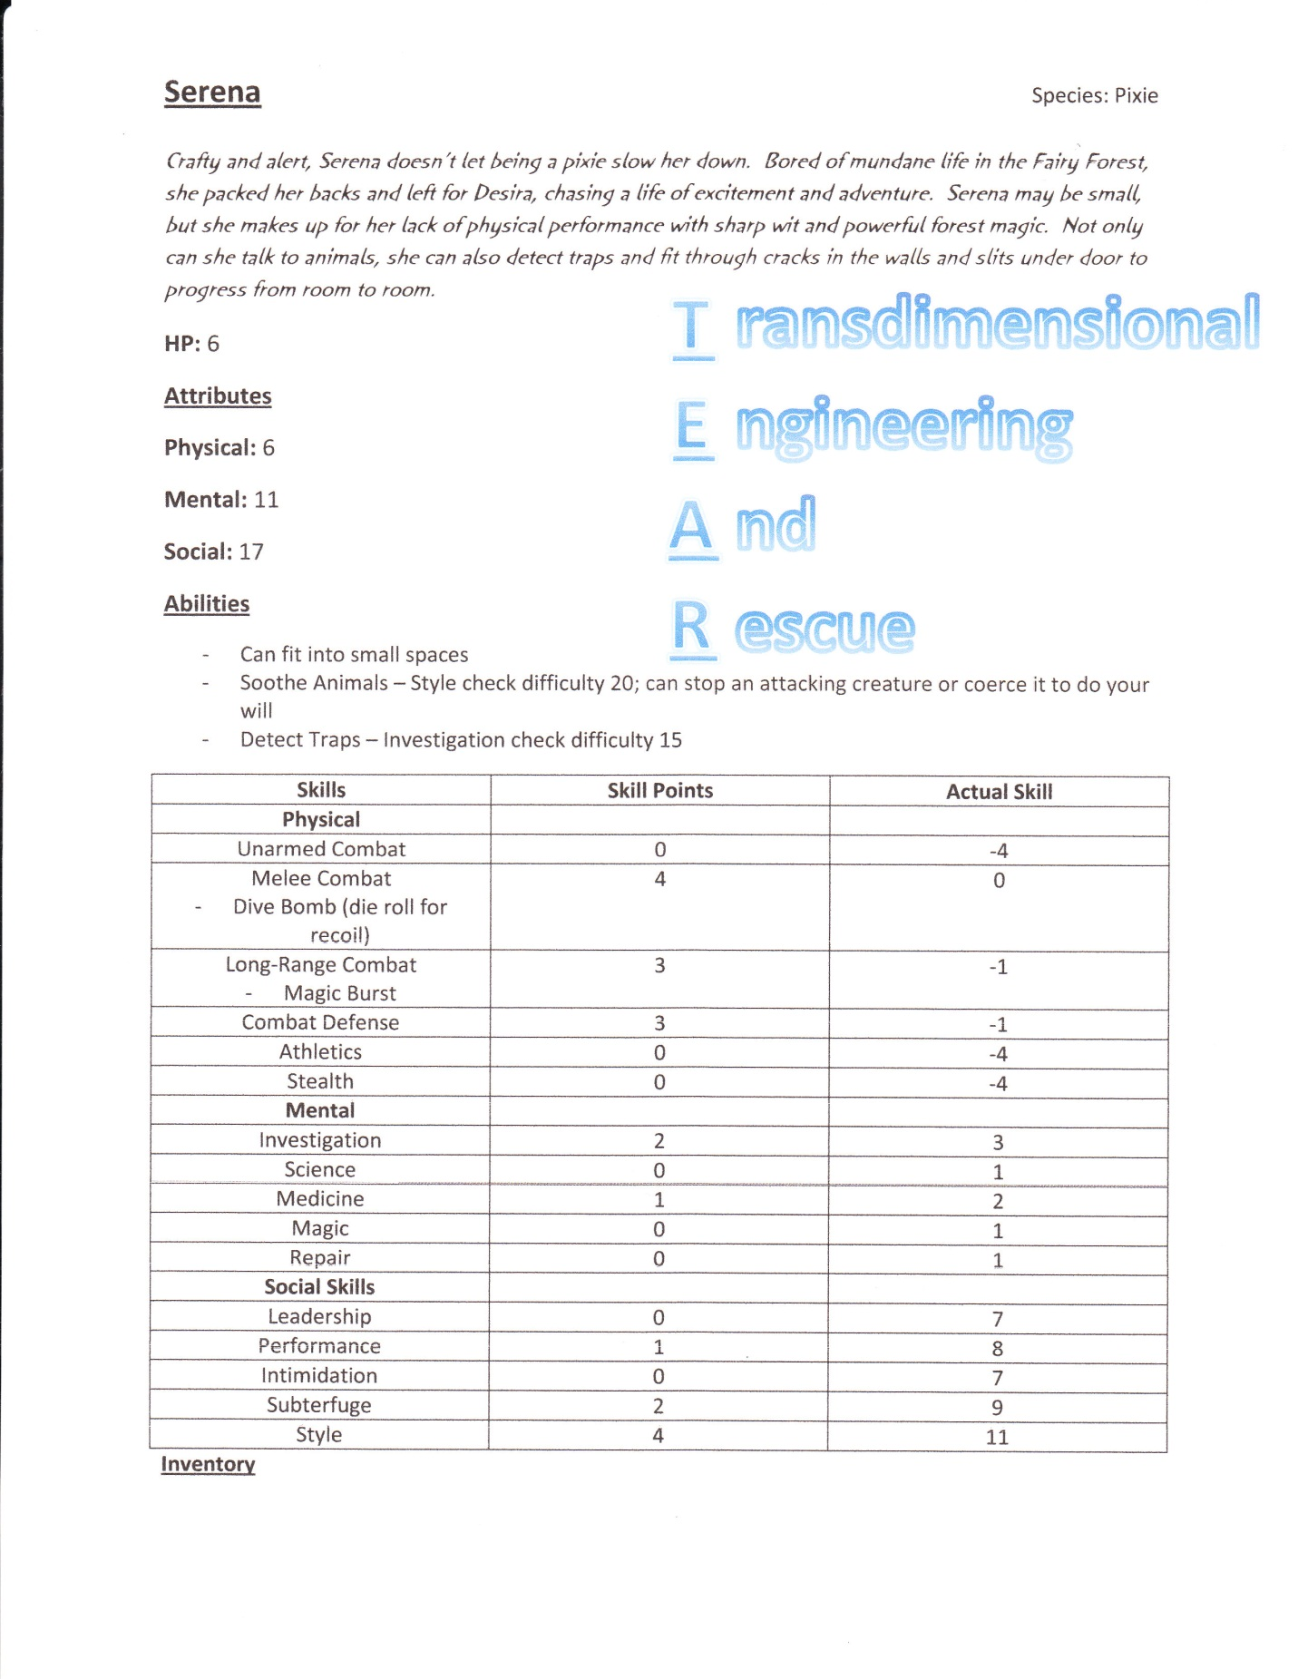

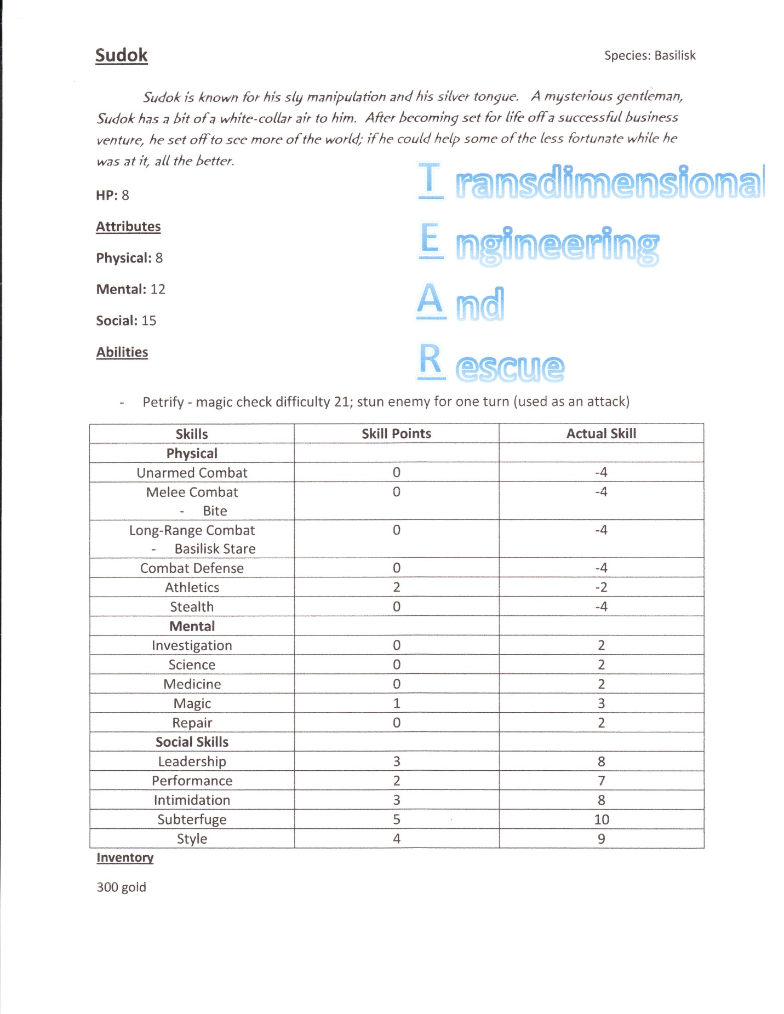

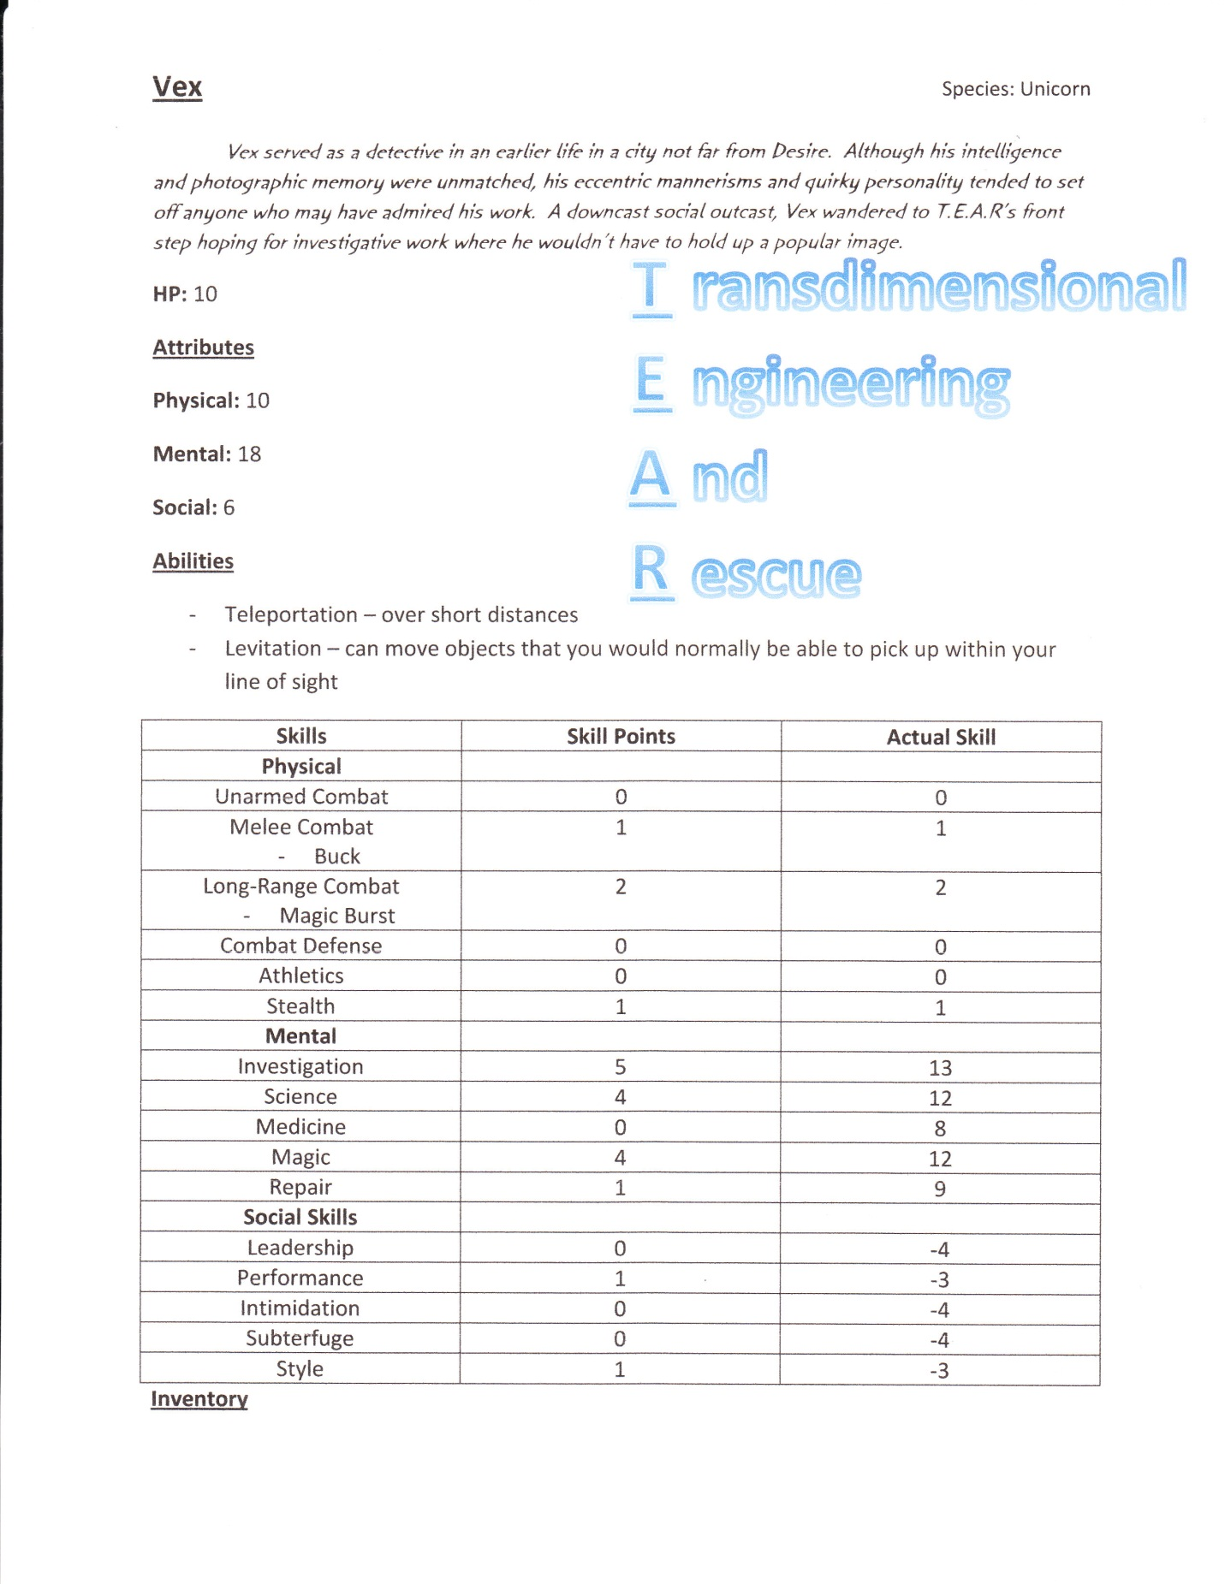

**T.E.A.R.**

**Backstory**

Originally, T.E.A.R. was a simple research organization dedicated to investigating the possibilities of interdimensional travel. The institute became a huge success when the first interdimensional teleportation device was developed. However, upon venturing into other worlds through their portal, what they found came as a surprise. Several other dimensions suffered poverty, droughts, and other calamities inflicted by a number of wicked individuals who took others’ prosperity for their own.

It became T.E.A.R.’s new mission to use this newfound technology to aid in the restoration of peace to these other dimensions, something that the members of Desira had begun to take for granted. Every year, new recruits are hired to take on missions, working towards a better multi-dimensional world one step at a time.

Located in the prosperous Desira, the T.E.A.R. building is considered one of the most impressive in the entire dimension. Its intimidating stature is seen as a symbol of protection for those in Desira and other adjacent dimensions under its protection.

**Introduction**

Mr. Bobbin

Symbol: Tie

*Mr. Bobbin is the recruit mentor who will give the players their introduction to the world of Desira. Being a new employee of T.E.A.R.’s rescue division himself, the company decided it would be best to start off by selecting a team of employees for him to work with. They provided him with the many applications T.E.A.R. received this season to peruse with a few colleagues. This is a first experience for everyone involved.*

*Mr. Bobbin is sociable, but down to earth. Although his demeanor may be misleading, he is typically described as being “cold as stone” by many who have worked with him for an extended period of time (a description not surprising for a gargoyle such as himself).*

Character Selection

Props: Pad folio, Character sheets

*Narration: “Welcome to Transdimensional Engineering and Rescue (or T.E.A.R. for short), the most prominent company in all of Desira. Originally centered on researching teleportation technology, T.E.A.R. got its start with the development of the famous interdimensional teleportation device. After a few visits into the unknown worlds on the other side of the portal hole, employees began to realize that not every dimension enjoys the prosperity, or the peace, that their home dimension took for granted. Determined to fix things in the adjacent dimensions, the company developed a branch specifically dedicated to saving those in need in alternate worlds, and first adopted the name T.E.A.R. (Transdimensional Engineering and Rescue). Now, as new recruits fresh out of training, it is finally your turn to select who you want to mentor through the rescue process.*

*You enter the conference room and are greeted by an official looking gargoyle slumped over a table. He motions for you to sit down in the chairs on the other side.”*

Mr. Bobbin: “Good evening *gentlemen, ladies, or both depending on who’s playing*. I take it you know the itinerary for today, but just to be sure, let me review the necessary tasks we have at hand. The T.E.A.R. board of directors has asked us to review the following applications and select two to add to our interdimensional rescue program. *\*Hands out character sheets\** Each one of you is to select one applicant to be your specific ‘representative’ so to speak. I will manage whatever missions you two may be asked to complete. I’m sure you’re familiar with the requirements, but I’m willing to answer any questions you might have about the procedure*. *Waits for players to make character selections, answering any questions they may have\**

*\*after players have made their choices\**

Mr. Bobbin: “Excellent! I’ll notify the selected applicants and have them in bright and early Tuesday morning. It was a pleasure working with the *number of players* of you, have a good night.”

The First Mission

Props: Pad folio, folder with first mission

*Narration: “The looming T.E.A.R. building appears to you like a stone giant, declaring its power not only to those native to Desira, but also those coming in through the equally impressive Hall of Portals (conveniently placed so the T.E.A.R. building is the first thing one sees when walking out).*

*As a young *player 1 species*, *player 2 species*, etc., you feel mixed emotions as you take the first steps towards an adventure whose caliber you can only begin to imagine. You enter the building and are greeted by *describe player characters*. They escort you to a conference room occupied by a lone gargoyle slumped over a table. He motions for you to sit down in the chairs on the other side.”*

Mr. Bobbin: “Ah, *gentlemen or ladies*, it’s a pleasure to finally be meeting you! First, allow me to congratulate you on being selected for one of the most prestigious positions the Desira dimension has to offer! My name is Mr. Bobbin, and I will be your mentor during your time here at T.E.A.R..

Your job here is simple, starting today, you will be given missions related to some problem being faced in some foreign dimension. This could by anything from retrieving a missing item or helping settle a dispute between two warring factions. I have your first assignment here in this folder *hands players folder with mission* which you can peruse at your leisure.

You will be working with the young spirit of a recently deceased Rocbird named Judavo. The death was an accident triggered by the neglectful experimentation of the wizard T’Nib. According to the rules of the newly established Otherworld Integration Pact, a ghost is no longer allowed to enter the otherworld without first eliminating the danger that caused his or her death. Hence, your mission is to aid him in somehow putting an end to T’Nib’s reckless experimentation, however you choose to do so. I realize this is a lot of information to throw at you at your first meeting, but I’m sure things will begin to make more sense the further you get into your assignment. Do you have any questions before we begin?

*Answers any questions the player may have about T.E.A.R., Desira, the mission, etc.*

“Good! Now, to begin your quest, take this paper down to the guards in front of the Hall of Portals, they should be able to explain things further. Judavo should be waiting there for you. The building is on the other side of the square directly outside this building. Now, hop to it! I expect to see this case solved as efficiently as possible.”

*Narration: “And so, your quest begins…”*

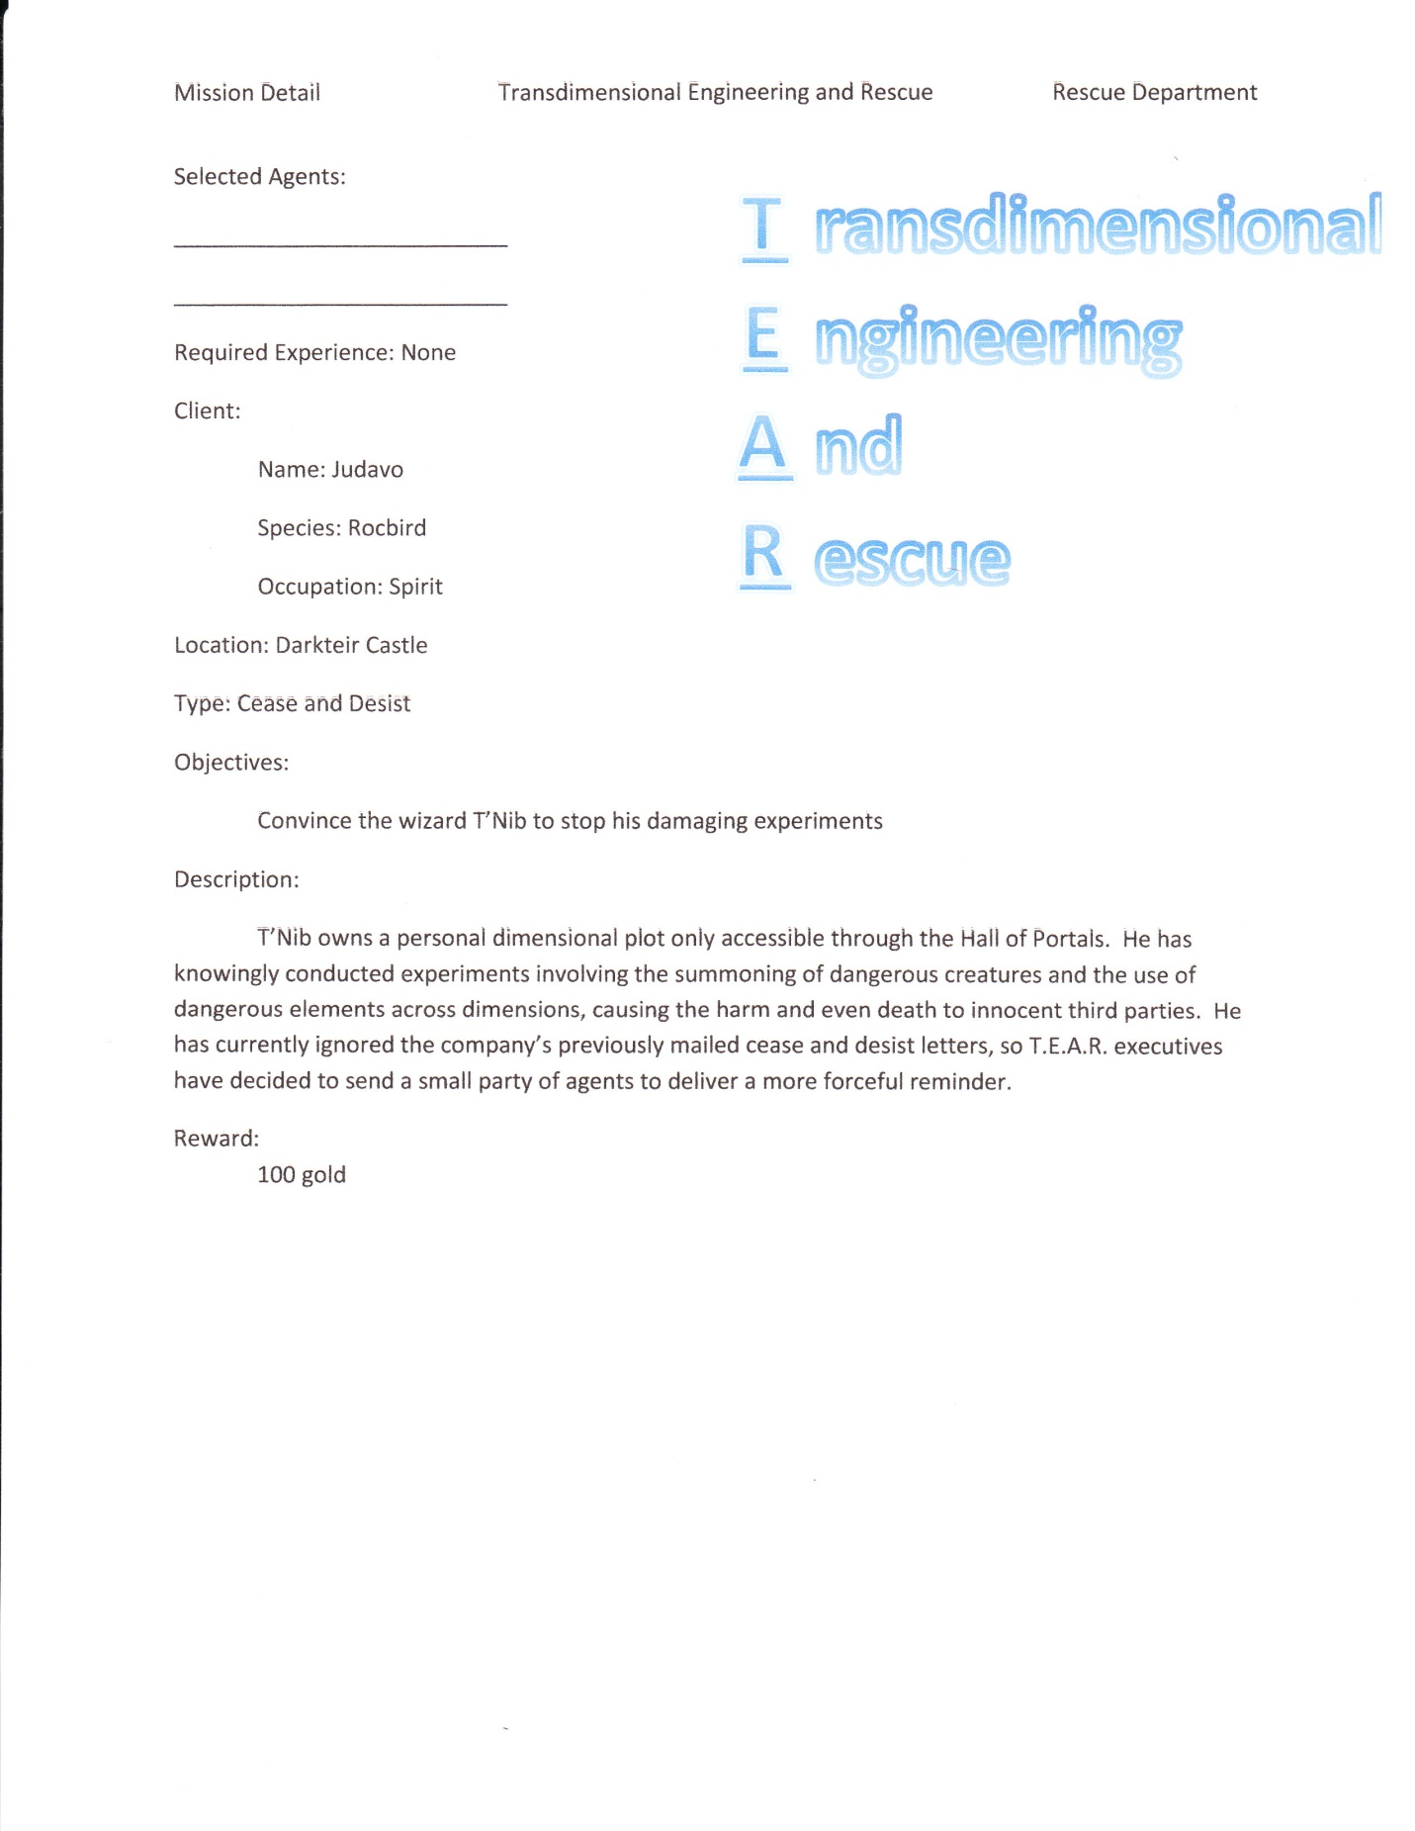

**Desira**

**Backstory**

Desira is a dimension that has seen prosperity for as long as anyone alive can remember. It is relatively small, especially compared to dimensions such as ours, but it stands as a formidable world nonetheless. Its main attractions consist of the T.E.A.R. building and its partner the Hall of Portals. These are used mainly by T.E.A.R. employees to travel to other dimensions on missions to aid the less fortunate, but are also occasionally leased out to the more wealthy individuals of Desira for short vacations.

The rest of Desira takes the form of a quant town, with most of the developments appearing in the West and North parts of the dimension, leaving the rest forested. Despite being only half developed, Desira has residents fairly evenly spread out throughout the town, fairly divided on which form of lodging they prefer.

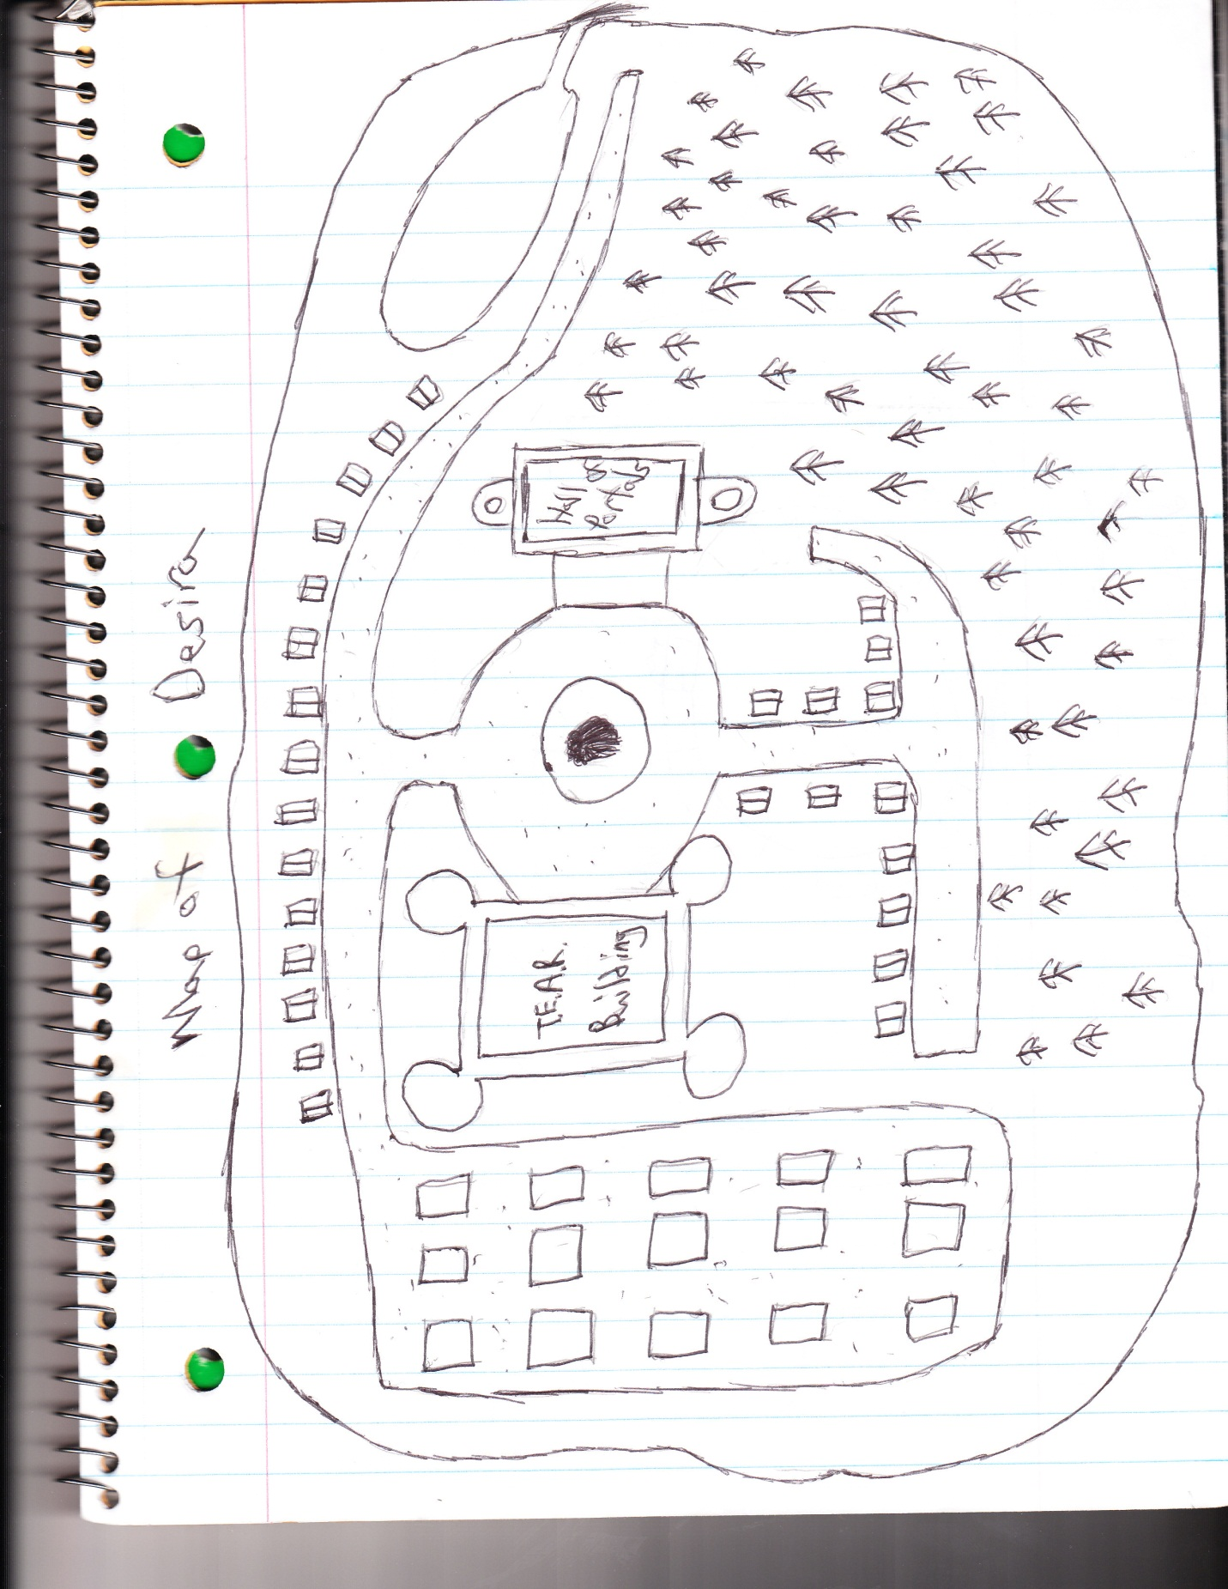

**Points of Significance**

*Storyteller note: these are to be used if the player goes into one of the houses of Desira, or meets someone in the forest. They do not have any particular location (the houses depicted on the map are generic for a reason). The only rules are that the hospital and NPC should be used in a house, and the Shop should be used in the forest.*

The Town

Hospital

*Narration: You walk into a large waiting room, the pungent aroma of cleaning fluids wafting from the polished walls and floors. Several benches and tables are spread out intermittently around the expansive room, leading up to a window with a lone unicorn nurse, who seems to be preoccupied with important paperwork. Above the window, you can see the words “Desira Hospital” painted in red letters.*

Nurse

Symbol: Red “Cross Badge”

If Players go up and talk to her: “May I help you *sir(s), mam(s)*?”

Will heal the party for a 10 gold charge each in the beginning

If it is mentioned that the players are part of T.E.A.R., they will get healed for free for the rest of the adventure

NPC House

Narration: You look around the house and see clutter everywhere. Clothes are draped over about every piece of furniture in the room, making it impossible to identify certain objects as anything more than “large”. Upon entering, a griffon in the other room hears the noise and comes to investigate.

NPC

Symbol: Generic NPC badge

Introduction: “Hey! Who do you think you are waltzing into someone’s house like that!?”

*Waits for response from the players*

*Probably ends with his kicking them out and leaving with a disgruntled expression*

Desira Forest

Shop

Upon entering the forest, the player must roll an investigation check of at least 15 to find the shop

*Narration: Upon entering the forest, one of the first things you notice is a partially hidden wood stand connecting two trees. The camouflage of wood on wood is so affective, that you probably would have missed it had you not been paying attention. Upon further investigation, you find that the stand is littered with various trinkets, from necklaces to water canteens. An imp wearing what appears to be a store uniform strolls out of the holes in one of the trees and notices you gazing at the merchandise.*

Shopkeeper: “Hello there! Are you interested in buying anything today? Let me know if you see anything you like, I’ve got more in the back too if you’re interested.”

Items Available in Shop

Sword (+4 melee attack)…………………………………100gp

Bow and Arrow (+3 melee attack)………………….100gp

Healing Kit………………………………………………………20gp

Water Canteen……………………………………………….10gp

Necklace (Style +3)…………………………………………75gp

**The Hall of Portals**

*Narration: You walk up to the Hall of Portals and are greeted by a pair of gargoyle guards. They have a significantly scrawnier stature than that of your boss, yet exhibit the same hunched over posture. The pair eyes you suspiciously as you approach, until one finally comes up to you and motions threateningly with his spear.*

Guards

Symbol: Conquistador hat

*Skittish and seemingly always on edge, the guards of the Hall of Portals aren’t quick to relinquish their trust to anyone, even after knowing them for a significant amount of time. The consequences are too great for them to take too many risks; their philosophy being that it would be better to bar possible legitimate travelers from the hall than to possibly let criminals have access to all that teleportation technology has to offer.*

Guard 1: “Alright, now hold up a second. Where do you think you’re going?”  
*Wait for player response*

*Guards don’t give players access to hall until they show their T.E.A.R. mission paper*

Guard 1: “Ah! You’re one of them T.E.A.R. people! Well, why didn’t you say so? *Looks at form* So, it appears you’re going to Darkteir Castle, eh? Nasty place that, heard they had a bit of a goblin problem not too far back. Anyway…I’ll go set up the main teleporter, you wait here.”

*Narration: “The guard goes inside the building, letting go of the door as he goes through. However, instead of closing all the way, the door stops halfway there. Suddenly, the image of a brown bird-like creature begins to materialize behind the obstructed door.”*

Judavo

Symbol: Kiwi Hat

Description: Judavo is witty, arrogant, and exceptionally lazy. Although his immense knowledge of Desira and its adjacent dimensions will provide useful, simply getting the necessary information out of him may become a task in itself.

The player can ask Judavo questions at any time, but he might not answer them in the way they want. He won’t solve puzzles. He won’t fight enemies. He only exists to further develop the story, provide a method for players to return to the game after they die (see a few notes on adventuring in the “Darkteir Castle” section), and provide backstory whenever players are interested.

Judavo: “Well if I had known that getting in would be that easy, I wouldn’t have spent all that time hiding here.” *inquisitively* “So, you’re the guys they sent to help with that stupid Otherworld contract. I’m Judavo, I’m the one paying you to sort out the problems someone else is causing. You? *Gestures towards the players, trying to strike up a conversation*”

*When the conversation with Judavo is over*

*Narration: “At this point, the guard returns, peeking his head through the doorway.”*Guard 1: “This way, please.”

*Narration: “The four of you march into the large shimmering building. Its architecture is even more impressive on the inside as it is on the outside. Dozens of archways and murals grace the ceiling above the main room. However, the most impressive piece of machinery is the large, dome-like structure in the middle. The gaping hole in the apparatus’s center is dwarfed by the compex bits of magical machinery and gizmos running what you assume must be the main interdimentional teleportation device.”*

Guard 1: “Ah yeah, she’s a real beauty isn’t she? Now, once you go through to Darkteir Castle, there will be another, smaller portal devise designed only to take you back here. Whenever you’re done with this little quest of yours, just pop back into the portal, and you’ll come right back to this building, completely unharmed (well, besides what may happen during your travels…).”

*Narration: “The yawning hole in the center of the machine lights up in a kaleidoscope of flashing colors, eventually settling on a picture of what you assume must be Darkteir Castle.”*

Judavo: “Ready?”

**Darkteir Castle**

**A Few Important Notes About Adventuring**

If the players die at any time throughout the adventure, they can be pulled back from the spirit world by Judavo…for a price.

If both players are dead, they are simply brought back to the beginning – all puzzles are solved, but all enemies are back (ie, if they found the bucket, they get to keep the bucket; if they defeated the hellhound, the hellhound returns after they die).

However, if one player dies, the ghost will allow the players the option to bring both of them back to full health at the start *or* to allow the second player to continue on from where he is. If he dies later on in the quest, there is no additional penalty, and both will return to the beginning healed. If he completes the quest, both characters will be returned to Desira fully healed.

Judavo: “Well, it looks like that didn’t quite go as expected. I guess you probably want me to bring you back now don’t you? *looks around* I’m technically not allowed to do this, but there is a way that I can return you to your world.”

*If both players are dead, bring them back to the beginning*

*If one player is alive*:  
Judavo: (continued on from before) “, but at a cost. I can either allow *alive player character* here to continue on with the quest from where you left off, or I can bring both of you back to the beginning of the castle fully healed. If you chose to continue with one person from where you are *dead player character* can aid as a spirit in solving puzzles, but he can’t physically do anything. So, what’ll it be?”

*At the end of both scenarios*:  
Judavo: “Alright…just…don’t tell anyone about this.”

Also, this roleplay uses a slightly more gradient method of determining damage dealt to the player. Weapons don’t play all that significant of a role, so critical hits will be determined by substantially large dice rolls. More specifically, the enemy dice roll, plus whatever modifier being applied to the attack (ranged combat, melee combat, etc.), minus the player character’s combat defense bonus must be at least a 10 in order to do damage. However, if it reaches a 20, it deals 2 damage. If the attack reaches 30 point, it does 3 damage.

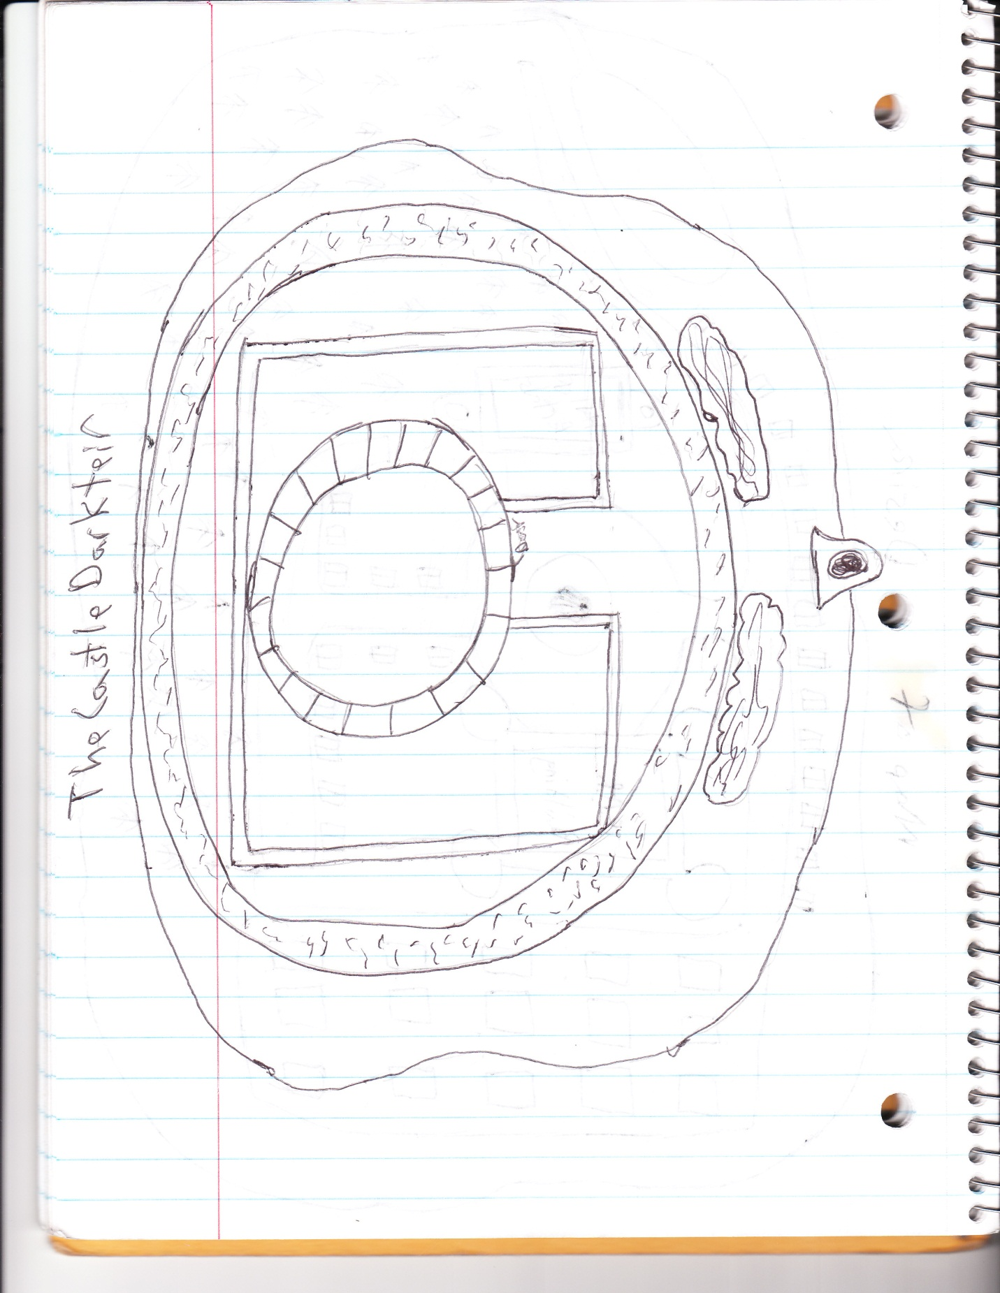

**Outside**

*Narration: As the swirling kaleidoscope of colors begins to die down and the spinning feeling in your head goes away, you find yourself face down in a large patch of grass. You get up, brush the dirt off yourself, and take some time to look around the new dimension you’ve entered. The first thing that surprises you is just how small it is, the land not extending far beyond the castle itself before dissolving into nothingness.*

*However, most puzzling is the landscape right in front of you. Just beyond a couple rows of bushes lies a moat with absolutely no bridge to speak of.*

Judavo: “Now, if I’m not mistaken, T’Nib tends to like to hang out on the top floor of his tower, which happens to be five floors tall. I don’t know what you guys want to do, but whatever the plan, I think that’s where we’re going to end up finding him.”

Outside the Moat – Objects to Interact with

The player can decide to investigate the bushes

* With an investigation check of 10 or more, the player will find a bucket
* With an investigation check of 17 or more, the player will find a bucket and a secret door down into the basement.

The player can choose to swim across the moat

* They will be attacked by sea creatures
  + Die roll of 1-10 means they are attacked by one creature
  + Die roll of 11-19 means they are attacked by two creatures
  + Die roll of 20 means they are attacked by three creatures

Sea Creatures

|  |  |  |  |
| --- | --- | --- | --- |
| **HP** | **Attacks** | **Skill Checks** | **Extra Effects** |
| 5 | Constrict (Melee) +0 | Player attacking creature  0-9: 0 damage  10-19: 1 damage  20-34: 2 damage  35-40: 3 damage | Can’t leave the water (takes the player three turns to cross the moat) |

If possible in the character description, the player can fly over the moat *to the other side*. However, if they try to fly to the top of the tower, they will be spotted by T’Nib and get hit with fireballs and lightning strikes (not only instantly dealing one damage, but knocking them back down to the ground).

A player playing as Vex can do a magic check to see if they can teleport over the moat. A 13 is required to make it over without falling in. A 23 is required if they want to teleport with a friend.

Courtyard

The player can try to open the door, but it is locked

* *Narration: “You attempt to open the door, but find that it is locked tight. You turn around to look for another solution, but are greeted by the sickening grin of a small hellhound waiting in the middle of the courtyard. As if an answer to your question, you see a key hanging around the animal’s neck. It stalks you threateningly, teeth barred and posed ready to strike.*
  + The player can attack the hellhound (see chart below)
  + If the player is playing as Serena, they can use her ability to soothe the hellhound (difficulty 16)
  + The player can try to take the key from its neck, which requires a stealth check of 10.
  + The player can try to run away, which requires a method to get over the moat (get attacked once if the move requires an action other than flying or swimming) and an athletics check of 13
  + The player can douse it with water (bucket) which is an instant kill
    - *Narration: “The creature rears back in agony, the water appearing to sear its very skin. After a short amount of time, the hellhound lies motionless on the floor.”*

|  |  |  |  |
| --- | --- | --- | --- |
| **HP** | **Attacks** | **Skill Checks** | **Extra Effects** |
| 15 | Bite (Melee) +7  Fire Breath (Range) +3 | Player attacking creature  0-14: 0 damage  15-24: 1 damage  25-34: 2 damage  35-40: 3 damage | Getting hit with water is an instant kill |

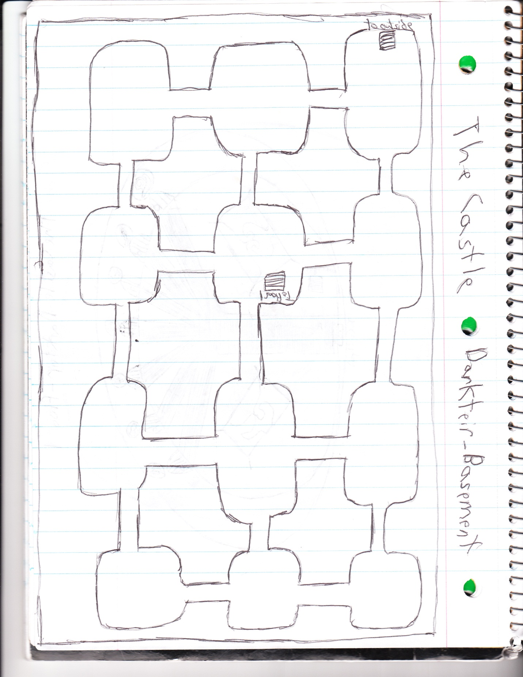

**Basement**

The player is given the map on the previous page, a large piece of paper with a hole in it is placed on top. Players can move one turn at a time, but they are also being followed by a minotaur who guards the basement. The minotaur starts in the middle room in the third column, and moves one room at random every turn (die roll 1-5 = move left, die roll 6-10 = move up, die roll 11-15 = move right, 16-20 = move down). The minotaur will mindlessly attack players and has nothing to give players who manage to defeat him.

|  |  |  |  |
| --- | --- | --- | --- |
| **HP** | **Attacks** | **Skill Checks** | **Extra Effects** |
| 17 | Axe Attack (Melee) +8 | Player attacking creature  0-16: 0 damage  17-30: 1 damage  31-40: 2 damage | Loses 5 points on his attack if his axe is broken (5HP, 0-9 = 0 damage, 10-19 = 1 damage, 20-40 = 2 damage) |

*Narrative: You tiptoe down the stairs into the basement below Darkteir Castle. You can barely see the walls of the room you’re standing in, but you can safely say that it is a fairly uniform block, with equally uniform hallways directly in front of you and to your right. Just as you are about to take your first steps into this unknown territory, you hear a disgruntled roar coming from a distance.*

*\*Investigation check (difficulty 15)*: It sounds like it could be coming from only 3 rooms away.*

*Every turn, report that the roar sounds like it’s coming from X rooms away if a successful investigation check can be completed*

*If minotaur finds party*

*Narrative: You see a brutish figure stumble into the room before you. When he emerges from the shadows, you see that it is a minotaur, ready to attack.*

Running away requires an athletic check of 15 from both players (player who doesn’t succeed gets attacked that turn).

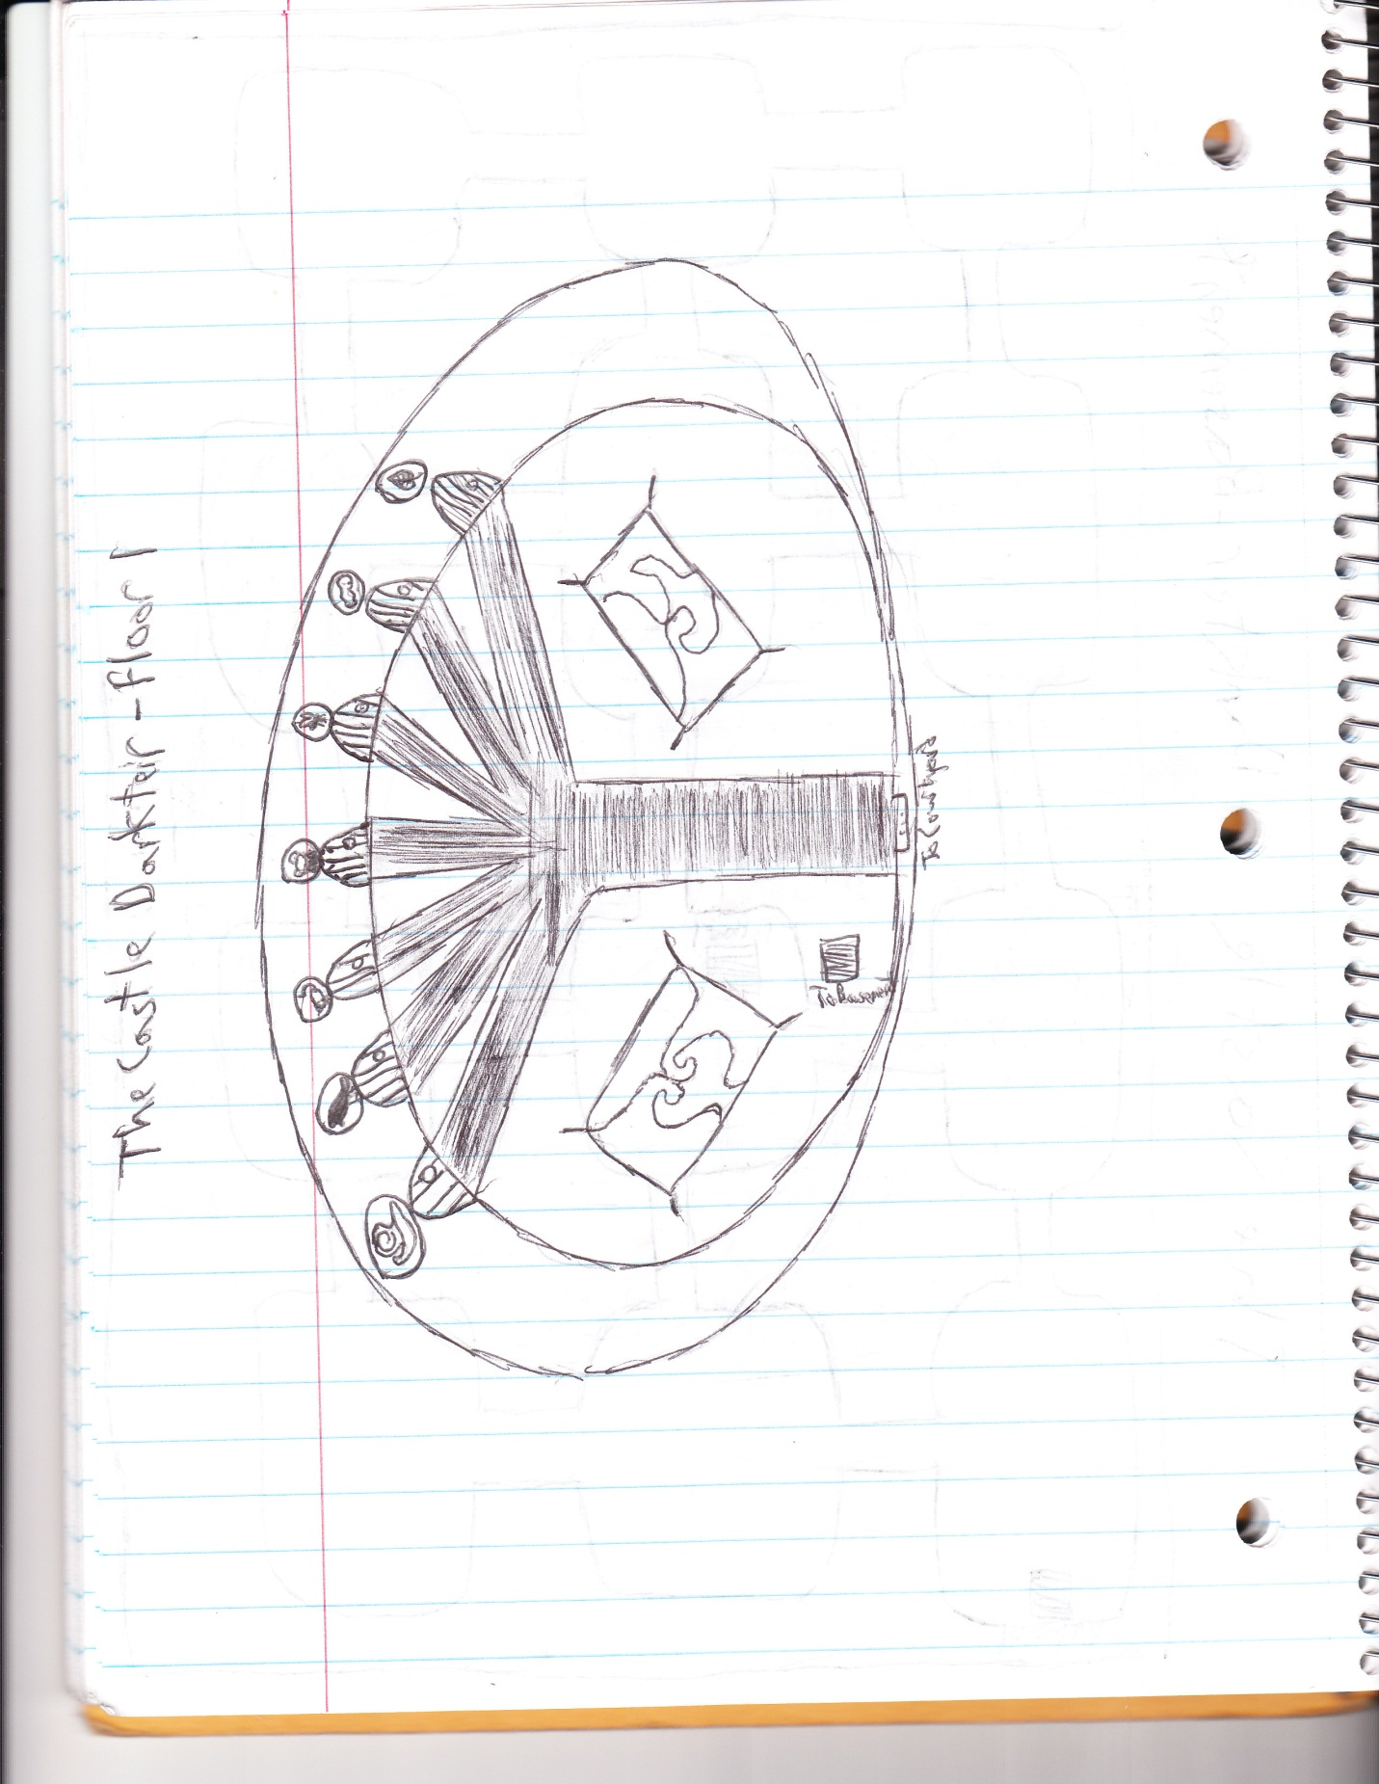

**Floor 1**

*Narrative: “The front hall of the tower is lavishly decorated. Chandeliers hang from the ceiling, and elegantly ordained carpet lines the majority of the floor. *If came from courtyard* A stairwell leading to a murky-looking basement lies immediately to your right. *If came from basement* A door strikingly similar to the one you saw at the front entrance is located directly to your right.*

*Straight ahead (or to your left), you see seven doors, each with a red carpet leading up to it and its own unique symbol branded above it. The symbols are: a snail, a crow, a mouse, a frog, a fly, a snake, and a leaf.*

*Correct answer is crow, because that is the only door whose symbol isn’t eaten by another animal on the list*

*If player selects wrong door*

*Narrative: “The door slowly creaks open, allowing you access inside. It seems rather dark, a little too dark for your comfort. In your puzzled curiosity, you don’t see the teeth closing down on the once open doorway…*

*If the player selects the right door*

*Narrative: “The door slowly creaks open, allowing you access inside. You see a pair of stairs, leading up to what appears to be the second story.”*

*\*If player selects the frog\**

*Narrative: “The door slowly creaks open, allowing you access inside. The room is surprisingly dark and barren, its walls and floors are completely bare except for the lone key sitting in the middle of the floor.”*

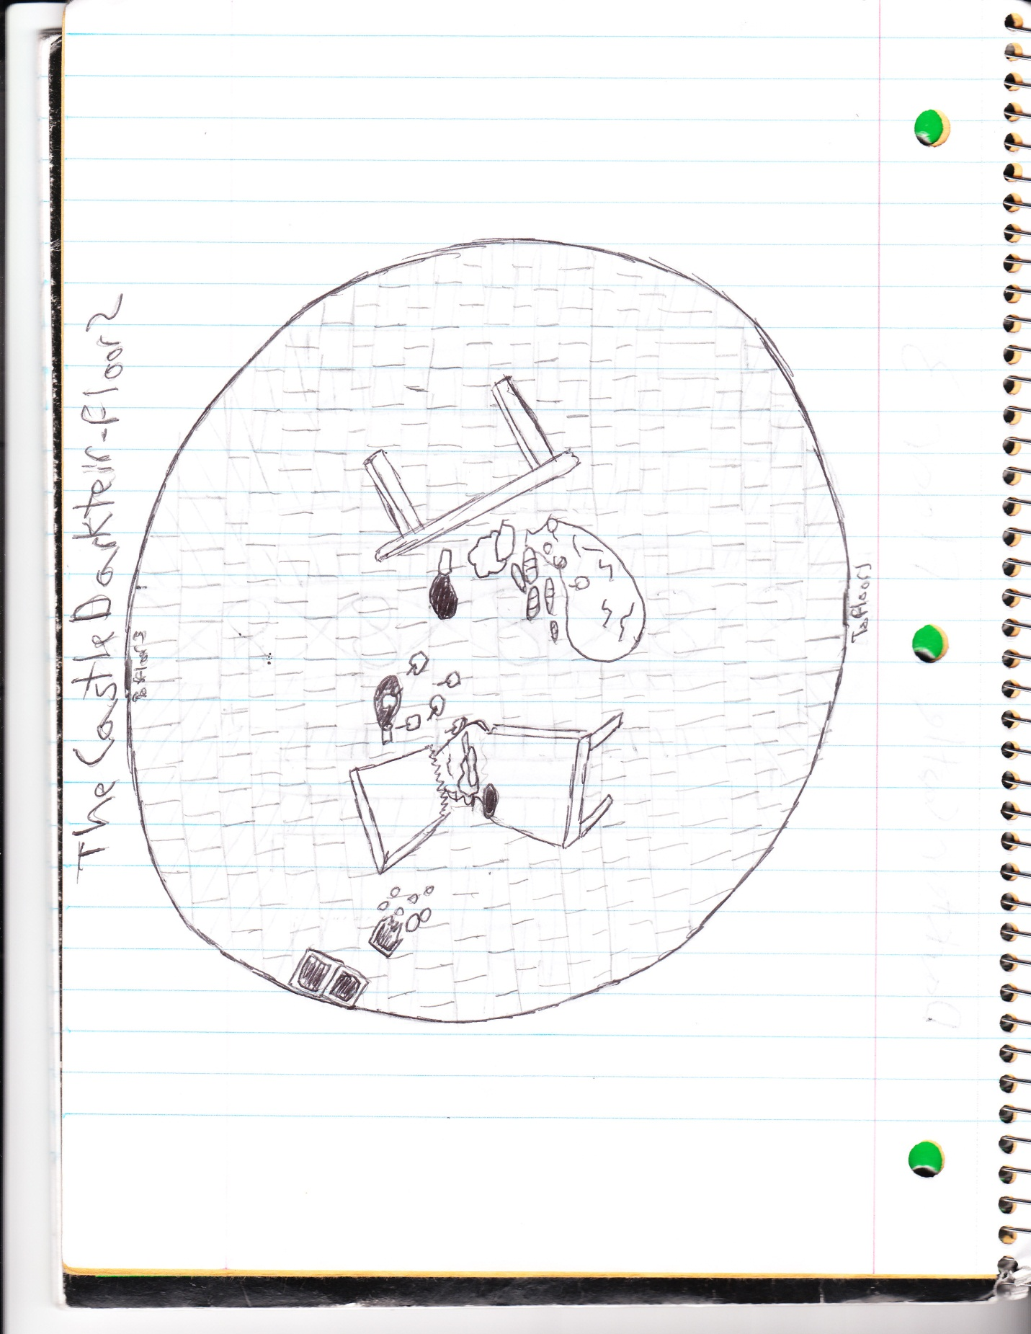

**Floor 2**

*Narrative: “You walk up to the second story, and find a dining hall whose stature matches that of the front hall. However, unlike the rest of the castle, this room is in complete ruins. Tables are overturned and even broken, food lies all over the floor. The culprit can be seen on the left-hand side of the room – a lone goblin hungrily munching on a handful of rolls that have spilled out of their container.”*

Player can sneak by the goblin with a stealth check of 10 from *both players*

Players can run past the goblin, with an athletic check of 10 from *both players* (the player who doesn’t roll high enough is attacked by the goblin one turn)

* If the players leave the goblin in the room, they will be forced to go by him again if they want to revisit earlier rooms again

Players can fight the goblin (details in chart below)

|  |  |  |  |
| --- | --- | --- | --- |
| **HP** | **Attacks** | **Skill Checks** | **Extra Effects** |
| 6 | Scratch (Melee) +1 | Player attacking creature  0-14: 0 damage  15-29: 1 damage  30-40: 2 damage | None |

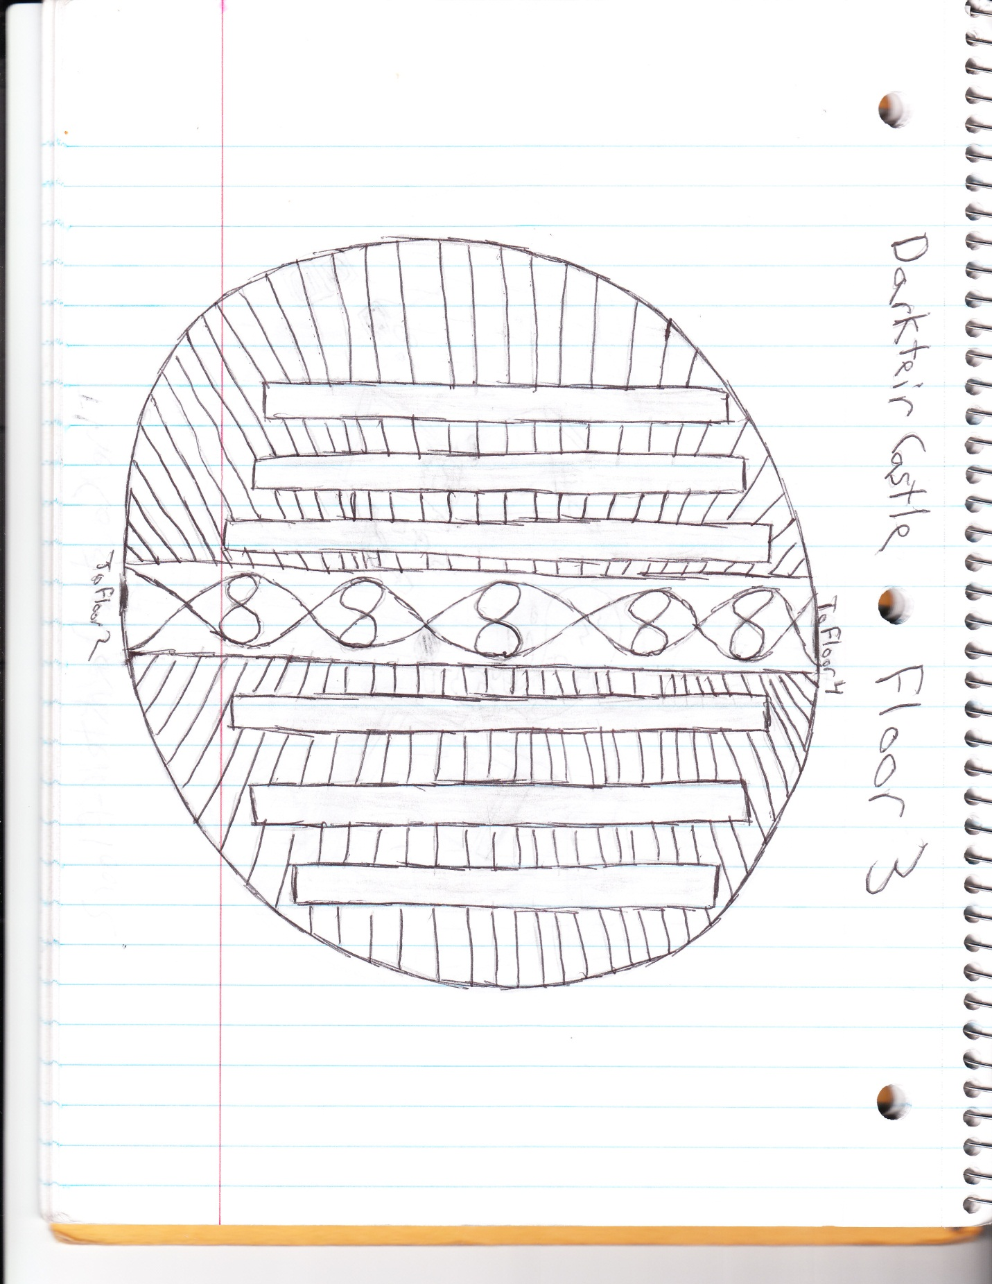

**Floor 3**

*Narrative: “The third floor of the castle is a large library, filled with rows of bookshelves containing hundreds of scrolls, books, and papers. Ornamental rugs decorate this room as well, leading your eye to another closed door on the other side of the room.*

*If the players try to open up the door, it is locked*

*If a player asks to take a book from the bookshelf, give them a real book with the following letter folded up inside of it*

*“A secret to help me find my key*

*When my fading memory begins to fail me:*

*Go back to a room from whence you came*

*Where instead of brawn, you used your brain*

*Through a door on neither side*

*Under an animal who eats the fly.”*

*Once the player has the key, allow them to go through the door to the next room*

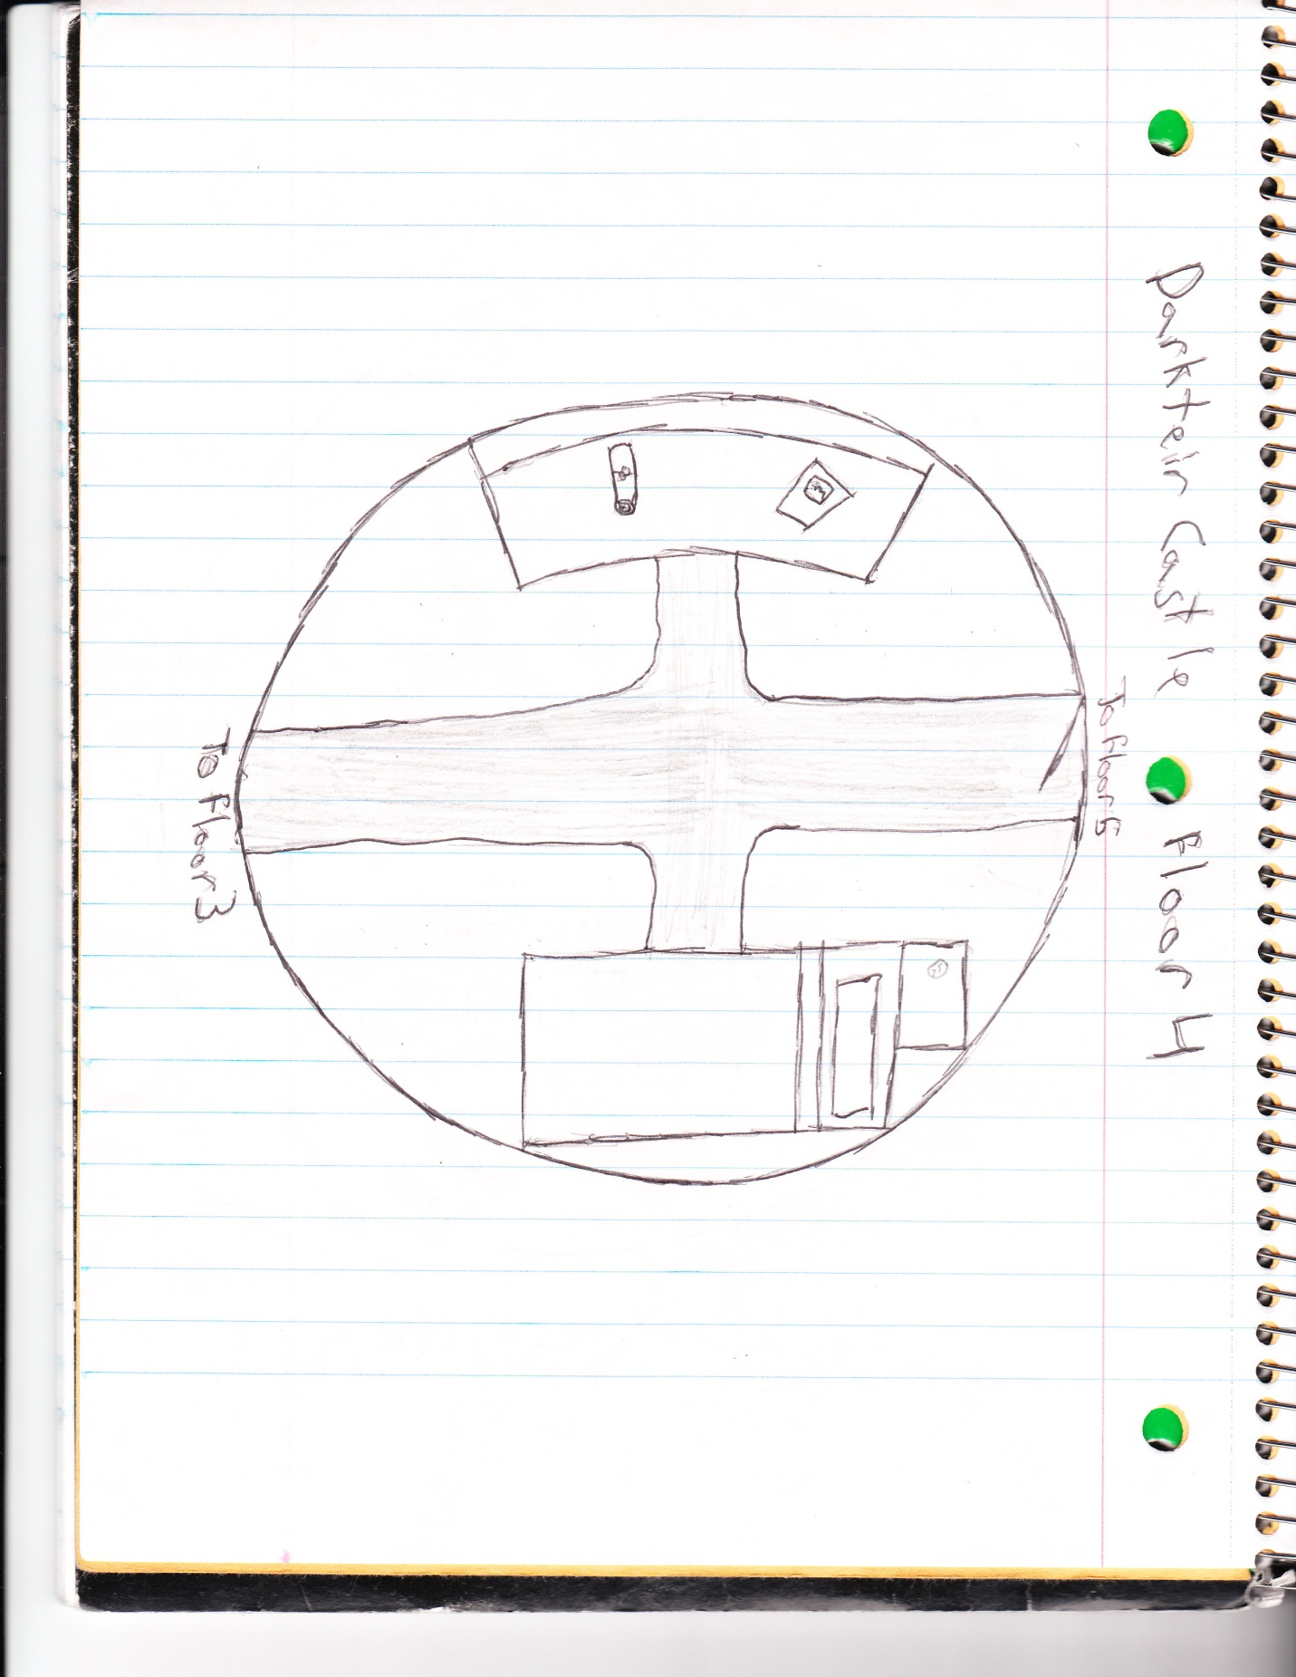

**Floor 4**

This floor is used mainly as a safety zone before the final confrontation with T’Nib. The only thing of significance here is the glass of water located on the night stand, which may come in handy later on.

*Narration: “You walk in on a bedroom, which seems to be relatively quiet compared to the rest of the castle. A brightly colored rug makes a cross in the middle of the room, leading to a desk and a bed on either side. A door is left lazily open on the opposite end. Though not as messy as the dining room, several articles such as books and scrolls lie around the room. A glass of water has been left on the night stand next to the bed.”*

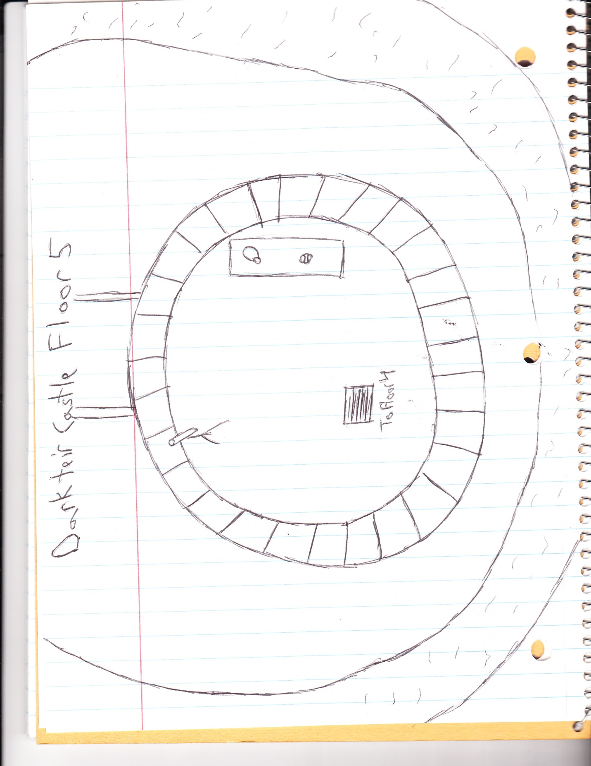

**Floor 5**

*Narrative: “You come to the end of the staircase, realizing that it has taken you to the top of the tower. Sure enough, just like you were told, T’Nib stands just in front of you, facing in the opposite direction.*

*An old ragged griffon with a fiery red coat, the wizard appears to be just about as menacing as his descriptions are. He calmly addresses you as you come to the top of the staircase, but doesn’t turn around.”*

T’Nib

Symbol: Wizard’s Hat

Description: T’Nib is a griffon wizard who makes a living conjuring creatures and making magical brews. His slightly unstandardized methods have caused more than one catastrophe, and T.E.A.R. has begun to take notice. T’Nib argues that his magic is the only way that he is able to support himself, and that T.E.A.R. has no right to remove him from his job just so they can impose their ethics onto those from other dimensions.

T’Nib: “Ah, you must be those T.E.A.R. guys come to pay me a visit. Well, you can send Mr. Bobbins my regards, and let him know that I’ve refused to accept his outlandish requests.”

* Players can try to persuade T’Nib, which requires a style skill check of 30
* Players can also attack T’Nib, detailed in the chart below

|  |  |  |  |
| --- | --- | --- | --- |
| **HP** | **Attacks** | **Skill Checks** | **Extra Effects** |
| 20 | Fire Blast (Range) +5  Lightning (Range) +5 | Player attacking creature  0-19: 0 damage  20-29: 1 damage  30-40: 2 damage | Has a magic shield cast that decreases player attack rolls by 10  Players can attack the shield; it breaks if they can get an attack skill ckeck of 20 or more; T’Nib is stunned for one turn when his shield is broken |

* However, perhaps the easiest method is the use of water. T’Nib’s relation with fire magic has been implied throughout the roleplay. Getting him wet in any way breaks his shield instantly and deals 10-20 damage depending on the quantity.

**Ending + Epilogue**

The end of the quest is more or less determined by the actions of the player. Overall, if the player ends up stopping T’Nib from his nefarious experiments, Judavo is finally allowed to enter the spirit world, and may permanently say goodbye to the group. However, if the group has treated him well during the adventure, there is the possibility he could become a permanent part of your team.

Upon arriving back at the T.E.A.R. building, Mr. Bobbin acts surprised that the players were able to finish the mission so quickly. He will give them their reward money, and then discuss what their next assignment should be. This is not included in this booklet (assuming what’s here will take up most if not all of the roleplaying time).

Mr. Bobbin will encourage the players to take some time to explore that various shops and buildings of Desira, not only killing more time before the unplanned mission, but to also include the points of significance from the “Desira” section more prominently. It also allows them to spend their earnings on improving their character.

Works Cited

<http://www.rinkworks.com/namegen/>

<http://tvtropes.org/pmwiki/pmwiki.php/Main/HomePage>

<http://www.mythicalcreaturesguide.com/page/List+of+Mythical+Creatures>

<http://listverse.com/2007/07/26/top-10-mythical-creatures/>

<http://fantasy.fictionfactor.com/articles/mythological.html>

<http://www.roll-dice-online.com/>